Instructions to Run

VTT (Vulcan Transit Tracker)

Robert Breckinridge

Anthony Carrola

Michael Gorse

Paul MacLean

Our senior project is difficult to run without the appropriate knowledge. There is a large amount of upfront setup required. A server must be acquired and have Apache Tomcat installed on it. For more information on how to install Apache Tomcat see the documentation on Apache Tomcat’s Website (Maucherat). Once Apache Tomcat is installed on the server, upload and deploy the VTT.war file that we have supplied. More information on deploying files can be found in the documentation on Apache Tomcat’s website (Crossley). After the war file is deployed, data can be sent to the server from an external test server or from the tracking unit that we have created.

We have created a Lua script to send test data to the server. This is included in the files that we have submitted. This script can be ran using Roblox Studios. More information about how to download Roblox Studios can be found in this article discussing how to download Roblox Studios (“How to Install and Play Roblox Using Browser”). For more information regarding the use of Roblox Studios, refer to this article (Roblox). The only thing that would need changed to send data to the server when using the Roblox script is the data contained in the variable link. It should be changed to the web address of the server, plus the port number Apache Tomcat is hosted through on the server. This would only need done when using a server other than the one it is currently being hosted on.

To send data using the tracking unit that we have created, turn it on using the power switch and wait for any route button to respond to user input. When a route button is pressed, its corresponding light should be lit up. Once data is being sent to the server, it will be automatically sent to the client-side webpage. This can be opened using any web browser with the web address of the server, plus whatever port number Apache Tomcat is hosted through on the server with “/VTT” appended at the end of the string. This project can be hosted on any server. However, our current version is being hosted at the following domain: <http://hwsrv-698431.hostwindsdns.com:8080/VTT/>.

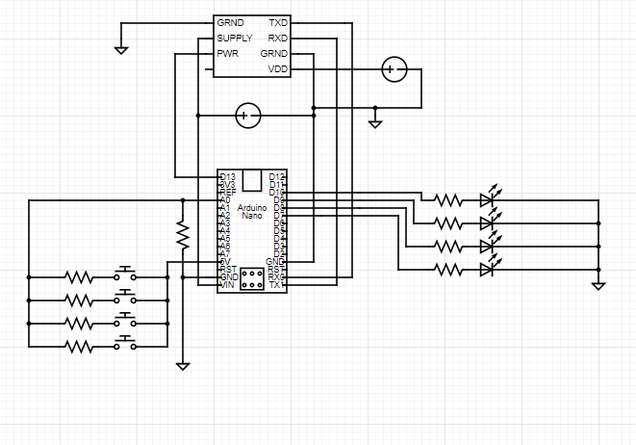The hardware portion of the project requires good knowledge of microprocessors. The materials list for the GPS unit is 1 Uno Nano Board, 1 SIM7100A cellular module, 1 activated sim card, 4 LEDs, 4 buttons, many jumper wires, resistors, 1-2 9V batteries regulated at over 1000mA, 1 small breadboard (optional). Below is the circuit used in the project.

Once the circuit is set up, the arduino nano needs to be loaded with the arduino program consisting of 7 files that were submitted. This can be done using the arduino IDE. Once properly powered and loaded with the program, click the button on the arduino nano to start running the program. The cell module takes time to start up initially, but once the first coordinates are pulled, the cell module runs smoother and more consistently. Once running smoothly, the buttons will be able to be pressed to activate the route selections.

Bibliography:

Crossley, Allistair. “Apache Tomcat 8.” *Apache Tomcat 8 (8.5.54) - Tomcat Web Application Deployment*, tomcat.apache.org/tomcat-8.5-doc/deployer-howto.html.

“How to Install and Play Roblox Using Browser.” *Roblox Support*, en.help.roblox.com/hc/en-us/articles/204473560-How-to-Install-and-Play-Roblox-Using-Browser.

Maucherat, Remy. “Apache Tomcat 8.” *Apache Tomcat 8 (8.5.54) - Tomcat Setup*, tomcat.apache.org/tomcat-8.5-doc/setup.html.

Roblox. “Roblox API Reference Manual.” *Roblox Developer Hub - Learn How to Create Games on the Roblox Platform*, developer.roblox.com/en-us/api-reference.